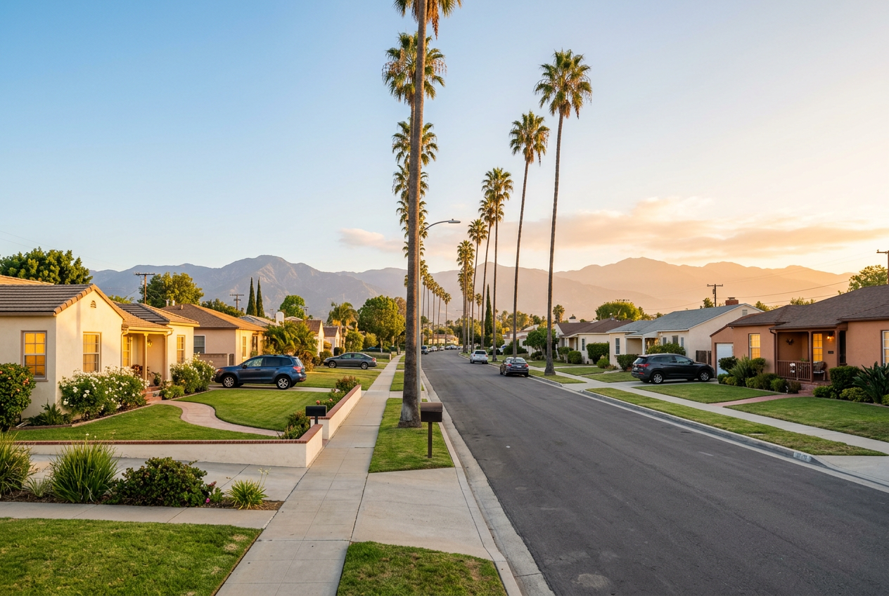

Most Affordable Places to Live in Los Angeles
The most affordable places to live in the Los Angeles area are Lancaster and Palmdale for houses, and Panorama City and Boyle Heights for city living.
Lancaster homes sell for about $460,000, and a one-bedroom in Panorama City rents for about $1,630, according to Nora Da Real Estate.
Low prices usually mean a longer drive, so this guide shows the price, rent, and trade-off for each area.

Affordable Places to Live in Los Angeles at a Glance
Area | Type | Typical home price | Typical rent | Worth knowing
Lancaster | Outer suburb | About $460,000 | About $1,760 (all unit sizes) | Far out in the Antelope Valley
Palmdale | Outer suburb | About $500,000 | About $1,800 (all unit sizes) | Quiet, small-town feel
La Puente | Suburb | Some homes under $700,000 | Check listings | About 20 miles from downtown
Pomona | Suburb | About $690,000 | About $1,810 (all unit sizes) | Easy access to LA and the Inland Empire
Panorama City | City neighborhood | About $670,000 | About $1,630 (1 bedroom) | Inside the city, in the Valley
Boyle Heights | City neighborhood | About $670,000 | About $1,640 (1 bedroom) | Close to downtown, rich culture
Van Nuys | City neighborhood | Check listings | Check listings | Often listed among low-cost rentals
Suburb rents are U.S. Census Bureau medians for all unit sizes (2020 to 2024). Neighborhood rents are one-bedroom averages. Prices are medians or typical values and change by month.

Affordable Suburbs in LA County
According to LA Metro Home Finder, Lancaster and Palmdale have the lowest median home prices in LA County, at around $450,000 to $500,000. The U.S. Census Bureau's figures below cover 2020 to 2024, so they run lower than today's market prices. The other suburbs cost more but sit much closer to the city.

Lancaster
Lancaster homes sell for a median price near $460,000. The Census Bureau puts the median home value at $446,600 and median rent at $1,764. The city lies far out in the Antelope Valley, about 60 miles north of downtown Los Angeles. One guide says rush-hour drives to downtown can take two hours.

Palmdale
Palmdale offers a quiet, small-town feel. The U.S. Census Bureau reports a median home value of $471,000 and median rent of $1,802. Zillow puts today's typical home value closer to $500,000. Like Lancaster, Palmdale sits in the Antelope Valley, so plan for a long drive to central LA.

La Puente
La Puente lies about 20 miles from downtown Los Angeles. That makes it much closer than the Antelope Valley. LA Metro Home Finder lists it among places with single-family homes under $700,000.

Pomona
Zillow puts the typical Pomona home value near $690,000. The Census Bureau's 2020 to 2024 median is $593,800, with median rent at $1,810. The city gives you easy access to both Los Angeles and the Inland Empire. That helps if your job or family sits east of LA.

Budget-Friendly City Neighborhoods
City neighborhoods cost more than the far suburbs. They also save you hours on the road.

Panorama City
Nora Da Real Estate puts one-bedroom rent near $1,630 and the median home price near $674,000. Panorama City lies in the San Fernando Valley, so you stay inside the city. Another guide shows one-bedroom rents of $1,300 to $1,750 across several low-cost areas. Sun Valley, Sylmar, Pacoima, and Arleta also list single-family homes under $700,000.

Boyle Heights
Boyle Heights sits closer to downtown. Nora Da Real Estate shows one-bedroom rent near $1,640 and a median home price near $672,000. The area offers rich cultural charm.

Van Nuys
LA Metro Home Finder lists Van Nuys among the most affordable places to rent in Los Angeles. ZIP code 91401 offers some of the Valley's lower-priced housing. Check current listings for exact prices.

What to Know Before You Pick a Low-Cost Area

Think About Your Commute First
A lower price often means a longer drive. Count the time and the gas before you decide.
- Lancaster: a very long trip to downtown at rush hour
- La Puente: about 20 miles to downtown
- Panorama City and Van Nuys: inside the city, with shorter trips across the Valley

Compare Renting and Buying

If You Rent
Renting keeps your upfront cost low. A one-bedroom in Panorama City costs about $1,630 a month.

If You Buy
Buying costs more up front, but you own the home. Zillow puts the typical Los Angeles County home value near $873,000, so the areas above cost far less.

Plan for Costs Beyond the Price
- Property tax: California starts at 1% of the purchase price, and local charges add more.
- Closing costs: Buyers often pay 2% to 5% of the price.
- HOA fees: Condos and townhomes charge monthly dues.
- Insurance: Get a quote before you make an offer.
- As-is homes: Many lower-priced homes sell as-is, which means the seller won't make repairs. The seller must still tell you about problems they know of. Andrew's guide to selling a house as-is in California explains how these sales work, so you know what to ask before you offer.

Want a More Central Home? Neighborhoods Andrew Knows Best
A long commute is a deal breaker for many people. If that is you, look closer to the middle of LA. These neighborhoods cost more, but they offer walkable streets, schools, and quick freeway access. Condos give you the lowest way in.
Neighborhood | Entry point | Typical median price | Known for
Valley Village | Condos from about $600,000 | About $1.1M to $1.4M | Quiet, tree-lined streets
Sherman Oaks | Condos about $600,000 to $950,000 | About $1.3M to $1.7M | Ventura Boulevard and freeway access
Studio City | Condos and townhomes | About $1.8M | A walkable village feel
Hollywood Hills | Condos about $600,000 to $1.2M | About $1.7M to $2.4M | Views and privacy
Prices come from recent local market reports and change often. Ask Andrew for current sales in each area.
Read more about each area:
- Valley Village has quiet streets and the best value of the four.
- Sherman Oaks splits into flat streets north of Ventura and hills to the south.
- Studio City offers a walkable village close to the Cahuenga Pass.
- Hollywood Hills puts views and privacy first.
Ready to compare? Browse homes for sale in Los Angeles and filter by price, bedrooms, and property type.

Frequently Asked Questions

What is the cheapest place to live in Los Angeles?
Lancaster and Palmdale have the lowest home prices in LA County, at around $450,000 to $500,000. Inside the city, Panorama City is one of the cheapest places to rent. Your best pick depends on how far you can drive to work.

Where can I buy a home in LA for under $500,000?
Look in Lancaster and Palmdale in the Antelope Valley. LA Metro Home Finder lists 3- and 4-bedroom homes there from about $380,000 to $480,000. Check current listings, since prices move.

Where can I rent in LA for under $2,000?
Panorama City and Boyle Heights both show one-bedroom rents well under $2,000, near $1,630 and $1,640. The Census Bureau's median rents for Lancaster, Palmdale, and Pomona also fall under $2,000, at about $1,760 to $1,810. One 2026 guide gives a range of $1,300 to $1,750 for low-cost areas. Rents change by building and by month.

How much income do I need to rent in Los Angeles?
A common rule says rent should take 30% of your income or less. A $1,800 rent needs about $72,000 a year. Multiply your monthly rent by 12, then divide by 0.30.

Is Lancaster a good place to live?
Yes, if you want lower prices and more space. The trade-off is the commute, which can top two hours at rush hour. Remote workers often handle this best.

Is the San Fernando Valley cheaper than the rest of LA?
Parts of it are. Panorama City and Van Nuys cost less than most of the city. Studio City and Sherman Oaks cost more, so check each neighborhood.

Is it cheaper to rent or buy in Los Angeles?
Renting costs less each month. Buying costs more up front, but you own the home. Compare your full monthly cost, including tax, insurance, and HOA fees.

What is the cheapest safe neighborhood in LA?
No single area is both the cheapest and the safest. Safer areas often cost more. Check recent crime data for the exact street before you decide.

